Introduction to Basic Electrical Equipment’s



Spring 2022

CIRCUIT AND SYSTEMS 1 Lab

Submitted by: MUHAMMAD SADEEQ

Registration No.: 21PWCSE2028

Class Section: C

"On my honor, as student of University of Engineering and Technology, I have neither given nor received unauthorized assistance on this academic work.'

Submitted to:

Engr. Faiz Ullah

(April , 2022)

Department of Computer Systems Engineering University of Engineering and Technology, Peshawar

ASSESSMENT RUBRICS LAB # 01

Introduction to Basic Electrical Equipments

|  |  |  |  |  |  |
| --- | --- | --- | --- | --- | --- |
|  |  | **LAB REPORT ASSESSMENT** | | |  |
|  | **Criteria** | **Excellent** | **Average** | **Nil** | **Marks**  **Obtained** |
| **1.** | **Objectives of**  **Lab** | All objectives of lab are properly covered  [Marks 1] | Objectives of lab are partially covered  [Marks 0.5] | Objectives of lab are not shown [Marks 0] |  |
| **2.** | **Resistance,**  **Voltage &**  **Current** | Correct resistance, current and voltage statements and mathematical expressions are written. Circuit diagram shown is correct and properly labeled  [Marks 2] | Correct resistance, current and voltage statements or mathematical expression or circuit diagram is missing or circuit diagram is not properly labeled  [Marks 1] | Resistance, current and voltage statements, mathematical expression or circuit diagram are incorrect or missing. [Marks 0] |  |
| **3.** | **Digital**  **Multimeter** | Properly defined DMM and explained functionality in terms of voltage, current and resistance. Explain all steps required to calculate (voltage, current and resistance) measurement. Properly labeled DMM diagram is shown. [Marks 2] | DMM and its  functionality in terms of voltage, current and resistance are not properly explained. Steps required to calculate (voltage, current and resistance) measurement are partially shown. DMM diagram is shown but not labeled. [Marks 1] | DMM and its  functionality in terms of voltage, current and resistance are not explained. Steps required to calculate (voltage, current and resistance) measurement are not shown. DMM diagram is not shown [Marks 0] |  |
| **4.** | **Power Supply** | Power supply is properly defined. Functionality and steps to provide source voltage to circuit are shown. Diagram is shown with all labels and available voltage values.  [Marks 1] | Power supply is not well defined.  Functionality and steps to provide source voltage to circuit are not properly shown. Diagram is shown with no labels. [Marks 0.5] | No steps for functionality of power supply are shown  [Marks 0] |  |
| **5.** | **Bread Board** | Breadboard is properly defined. Functionality and steps to design series parallel circuit are | Breadboard is partially defined. Functionality and steps to design series | No steps for breadboard functionality are shown. |  |
|  |  | shown.  Open and short circuits are also defined.  Diagrams are shown with all labels. [Marks 2] | parallel circuit are not shown.  Information about open and short circuits are unsatisfactory.  Diagrams are shown with no labels.  [Marks 1] | [Marks 0] |  |
| **6.** | **Observations**  **&**  **Calculations** | All experimental results are completely shown in form of table for varying voltages and resistances.  [Marks 2] | Experimental results are partially shown and some of the observations are missing [Marks 1] | No experimental results are shown  [Marks 0] |  |
|  | Total Marks Obtained:__________  Instructor Signature: ______________________ | | | | |

**Experiment # 1**

Introduction to Electrical Lab Equipment

**Objective:**

To get familiar with the functionality and uses of different apparatus in the lab.

**Apparatus:**

1. Cathode Ray Oscilloscope
2. Digital Multimeter
3. Power Supply
4. Function Generator
5. Proto Breadboard
6. Connecting Wires

**Cathode Ray Oscilloscope:**

A device used to find frequency, time period, wavelength, shape of the wave signal and many different quantities is called Oscilloscope. These measurements are taken with the help of cathode ray tube that’s its called cathode ray oscilloscope. This device is widely used in the field of electronic for finding the behavior of different electrical signals in the circuit.

An oscilloscope is a type of electronic test instrument that allows observation of constantly varying signal voltages, usually as a two-dimensional plot of one or more signals as a function of time. Other signals (such as sound or vibration) can be converted to voltages and displayed.

Oscilloscopes are used to observe the change of an electrical signal over time, such that voltage and time describe a shape which is continuously graphed against a calibrated scale. The observed waveform can be analyzed for such properties as amplitude, frequency, rise time, time interval, distortion and others. Modern digital instruments may calculate and display these properties directly. Originally, calculation of these values required manually measuring the waveform against the scales built into the screen of the instrument.

The oscilloscope can be adjusted so that repetitive signals can be observed as a continuous shape on the screen. A storage oscilloscope allows single events to be captured by the instrument and displayed for a relatively long time, allowing observation of events too fast to be directly perceptible.

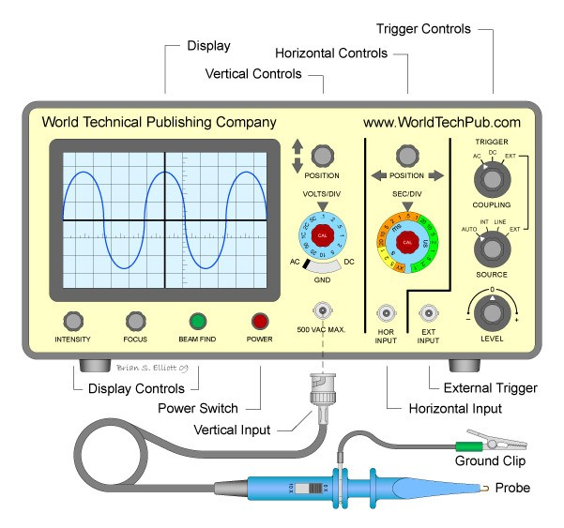

**Figure 1 Cathode Ray Oscilloscope**

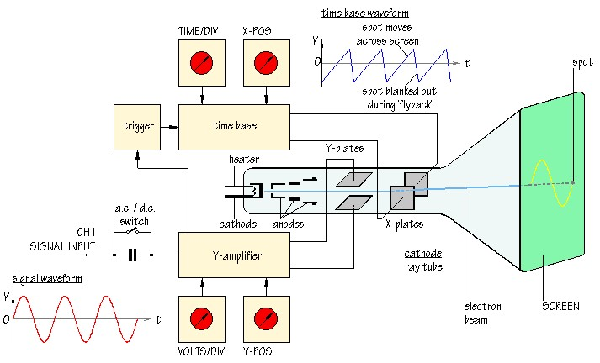

**Figure 2 CRO internal circuitry**

**Experiment:**

In order to know how to use CRO we did an experiment in the lab in which we compare the reading taken from the CRO to that of the actual readings. In this way we also find the error in our measurement.

First, we turned ON the CRO and adjust the knobs on the front panel in such way that the signal on the screen become stable and human readable. Then we connect one end of the cable to the CRO the other to the signal source then we take the required readings from the screen of the CRO.

**Observation:**

|  |  |  |  |  |  |
| --- | --- | --- | --- | --- | --- |
| Serial Number | Amplitude (volts Vp-p) | Frequency (Hz) | Time Period (s) | Frequency  Calculated  (Hz) | Error (%) |
| 1. | 2.25V | 1.4*104=14khz | 76*10-6 sec | 13khz | 7.14% |
| 2. | 2.0*0.5=1V | 1khz | 2.1*0.5=1.05sec | 0.95khz | 5% |
| 3. | 3.7*1=3.7V | 2Mhz | 1*0.5=0.5sec | 2Mhz | 0% |

**Digital Multimeter:**

Digital Multimeter is a device used to calculate resistance, voltage, current in a circuit. Previously device used for this purpose were analogue mean they would give reading using a needle which is not a very accurate method of reading so a new device was invented which give readings in digits and hence it is called digital multimeter.

Digital Multimeter are also called VOM (volt-ohm-meter) because of its multiple functionality. Digital Multimeter are cheaper and give greater precision over the analogue meters but still in some cases the analogue multimeters are preferred e.g when the value is rapidly changing. Multimeter is a handheld device it is usually used for finding errors and faults in the circuits.

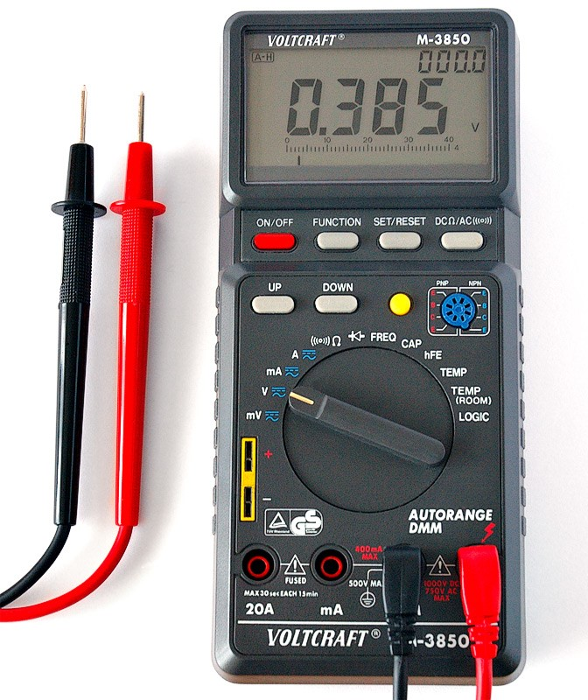

Figure 3 Digital Multimeter

**Function Generator:**

A function generator is usually a piece of electronic test equipment used to generate different types of electrical waveforms over a wide range of frequencies. Some of the waveforms produced by function generator are sinusoidal(sine), square, triangle, Sawtooth.

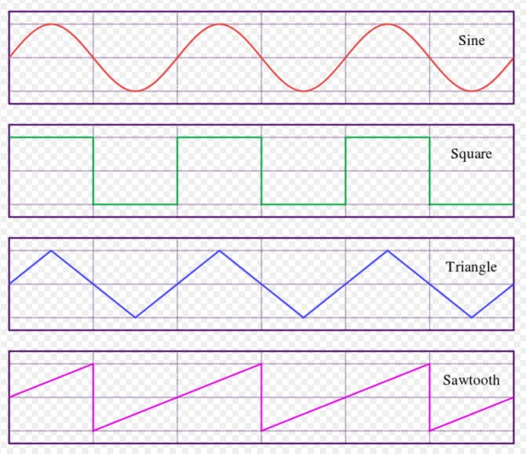

Figure 4 Waveforms

Function generators are used in the development, test and repair of electronic equipment. For example, they may be used as a signal source to test amplifiers or to introduce an error signal into a control loop. Function generators are primarily used for working with analog circuits, related pulse generators are primarily used for working with digital circuits.

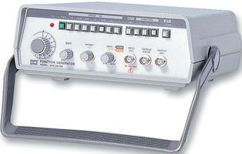

Figure 5 Function Generator

**Power Supply:**

A power supply is an electrical device that supplies energy to the circuit. The function of the power supply is to convert one form of electrical energy into another form. Power supplies can give us varying voltages and currents according to our need.

Power supply has single power input and have multiple power outputs. Power supplies are made in different sizes and capacities. In some devices the power supplies are embedded inside the device while in some machines the power supplies are external.

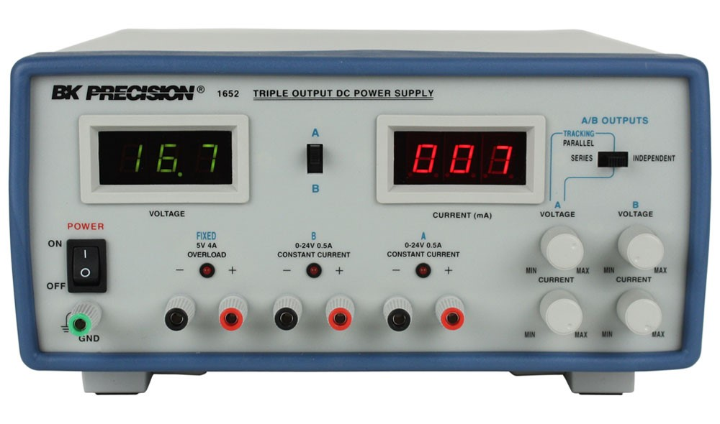

Figure 6 Power Supply

**Digital Multimeter:**

A digital multimeter (DMM) is a test tool used to measure two or more electrical values—principally voltage (volts), current (amps) and resistance (ohms). It is a standard diagnostic tool in the electrical/electronic industries.

Digital multimeters long ago replaced needle-based analog meters due to their ability to measure with greater accuracy, reliability and increased impedance.

Digital multimeters combine the testing capabilities of single-task meters—the voltmeter (for measuring volts), ammeter (amps) and ohmmeter (ohms). Often they include a number of additional specialized features or advanced options. Technicians with specific needs, therefore, can seek out a model targeted for particular tasks.

The face of a digital multimeter typically includes four components:

1. Display
2. Buttons
3. Dial (or rotary switch)
4. Input jacks

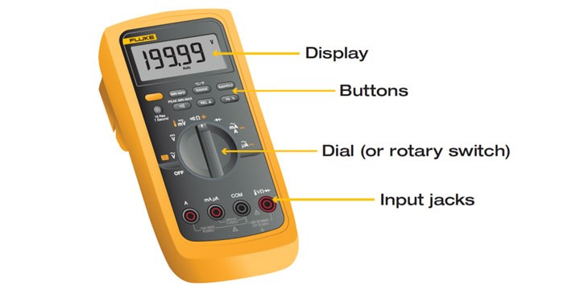

Figure 7 Digital Multimeter

The **Display** shows the digital reading on the screen. The reading is shown on the screen with digits.

The **Buttons** are used for different features in multimeter.

The **Dial** is used to set the range before taking the reading. It is good to set the dial at a range closer to the actual reading in order to get the accurate readings. Before taking the readings of the voltage it is a precaution to set the dial at minimum before taking the reading otherwise the device could damage.

The **Input jacks** are used to insert the knobs into the device in order to connect the apparatus for measurement. Different input jacks are used for measuring voltage and currents.

**Experiment :**

To find the voltage and current of power supply using Digital Multimeter.

**Procedure:**

1. Connect the knobs to the power supply and note the reading given on the power supply.
2. Connect the multimeter with the knobs, negative with the negative one and positive with the positive one.
3. Set the multimeter at the minimum to measure the voltage and then turn ON the power supply.
4. Note the readings from the screen of the multimeter.
5. Find the current using the formula .
6. Compare the readings taken from the multimeter with the actual reading of the power and find the percentage error.

**Observation:**

|  |  |  |  |  |  |  |
| --- | --- | --- | --- | --- | --- | --- |
|  |  | **Voltage** |  |  | **Current** |  |
| **Serial**  **Numbers** | **Power Supply (V)** | **Digital**  **Multimeter (V)** | **Error (%)** | **Power**  **Supply (I)** | **Digital**  **Multimeter**  **(I)** | **Error (%)** |
| 1. | 9V | 8.45V | 6.11% | 1A | 0.95A | 5% |
| 2. | 1.5V | 1.4V | 6.66% | 2A | 2A | 0% |
| 3. | 3V | 2.95V | 1.66% | 5A | 4.9A | 2% |